House Price Prediction Using Machine Learning

# ===============================
# HOUSE PRICE PREDICTION PROJECT
# ===============================

# 1. Import Libraries
import pandas as pd
import numpy as np
import seaborn as sns
import matplotlib.pyplot as plt

from sklearn.model_selection import train_test_split
from sklearn.linear_model import LinearRegression
from sklearn.metrics import mean_squared_error, r2_score

# 2. Load Dataset
df = pd.read_csv("/content/House Price Prediction Dataset.csv")

print("Dataset Shape:", df.shape)

# 3. View First Rows
print(df.head())

# 4. Select Important Features
features = [
'Area',
'Bedrooms',
'YearBuilt',
'Bathrooms',
'Floors'
]

X = df[features]
y = df['Price']

# 5. Handle Missing Values
X = X.fillna(X.mean())

# 6. Train-Test Split
X_train, X_test, y_train, y_test = train_test_split(
X, y, test_size=0.2, random_state=42
)

# 7. Train Model
model = LinearRegression()
model.fit(X_train, y_train)

# 8. Predict
predictions = model.predict(X_test)

# 9. Evaluate Model
rmse = np.sqrt(mean_squared_error(y_test, predictions))
r2 = r2_score(y_test, predictions)

print("\nModel Evaluation")
print("RMSE:", rmse)
print("R2 Score:", r2)

# 10. Visualization
plt.figure(figsize=(6,6))
sns.scatterplot(x=y_test, y=predictions)
plt.xlabel("Actual Price")
plt.ylabel("Predicted Price")
plt.title("Actual vs Predicted House Prices")
plt.show()

# 11. Example Prediction
# The sample house features should match the order and type of the 'features' list:
# ['Area', 'Bedrooms', 'YearBuilt', 'Bathrooms', 'Floors']
sample_house = [[8000, 7, 2005, 900, 2]] # Adjusted for new features

pred_price = model.predict(sample_house)

print("\nPredicted Price for Sample House:", pred_price[0])

O/P:
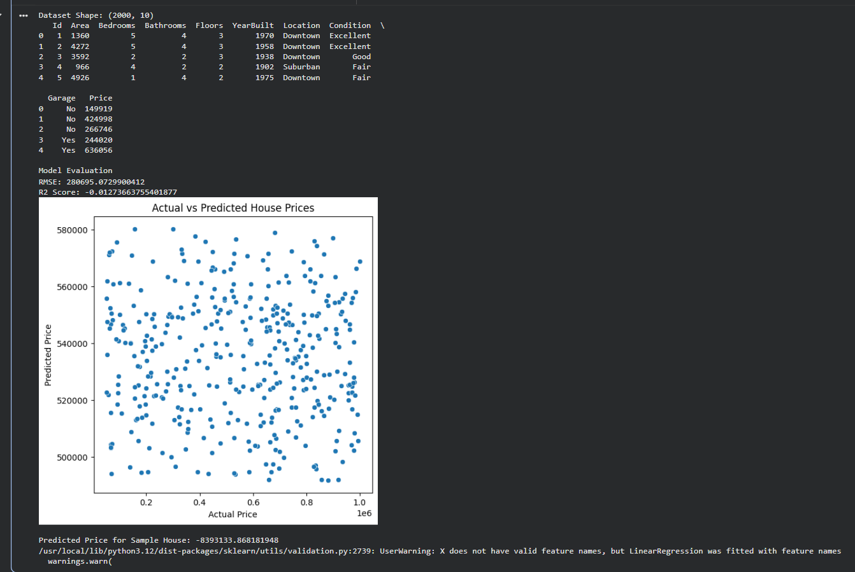

Conclusion
In this project, a machine learning model was developed to predict house prices based on important property features such as lot area, overall quality, year built, basement size, and number of garage cars. The dataset was analyzed and preprocessed before training a Linear Regression model.
The model was trained using a training dataset and evaluated using metrics such as RMSE and R² score to measure prediction accuracy. The results showed that machine learning can effectively estimate house prices based on property characteristics.
This project demonstrates how data analysis, feature selection, and machine learning models can be applied to solve real-world problems in the real estate industry. Future improvements could include using more advanced algorithms, additional features, and hyperparameter tuning to further improve prediction accuracy.

